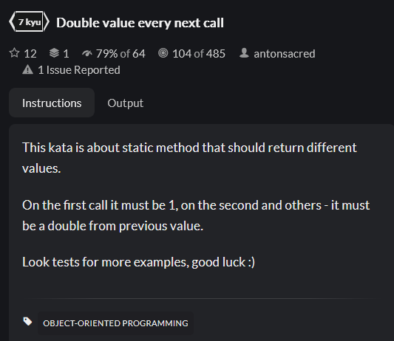

JS:

Key takeaways:

* Static methods and static properties are accessible from the Class and not from an Object i.e. instance of the Class.
* Static methods cannot access normal properties of the object as normal properties require an instance of the Class.
* Static properties can be accessed inside a static method via the this keyword.

Other solutions:

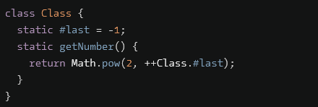

* Apparently # symbols can be used as names for static properties.
* Also, static properties can be access via the class name, even inside the class itself.
* The above solution stores the exponent of base 2, instead of the full value, a nice approach.

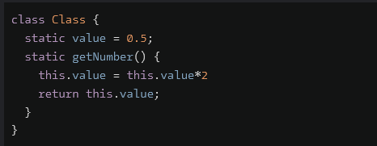

PHP:

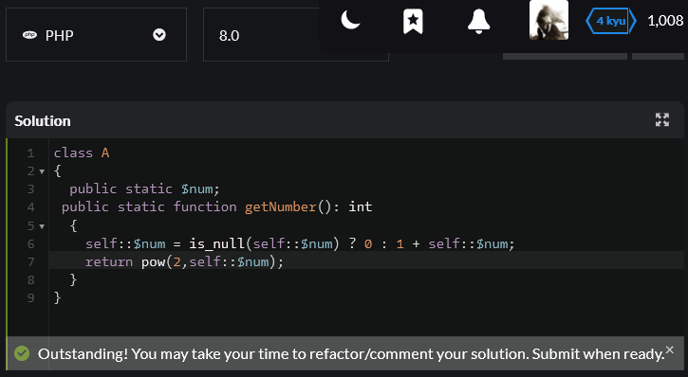

Takeaways:

* Static methods / properties need keywords and access modifier
* A class can be accessed within itself via the self keyword
* Static methods and properties can be access via the scope resolution operator (::) on the self keyword.
* The pow function is used for exponentiation. First parameter is the base, second is the exponent.

Other solutions:

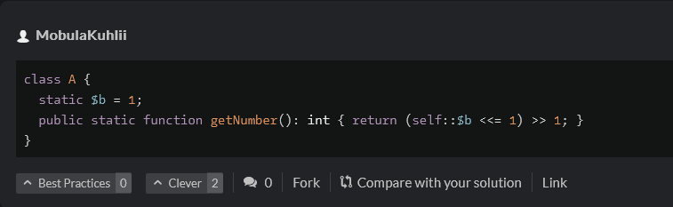

* Static properties do not need access modifier as the default is public.
* Bitwise shifting can make exponentiation with base 2 easier.
* Not very readable, not recommended unless speed is of utmost importance.

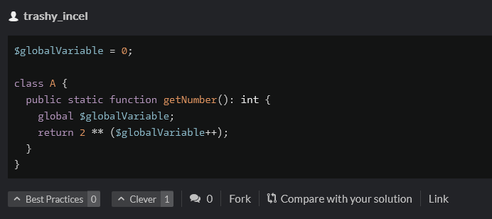

* Global variables can be used instead of static methods.
* Not recommended, as global variables have global scope, hence can be easily manipulated elsewhere in the program.

Python:

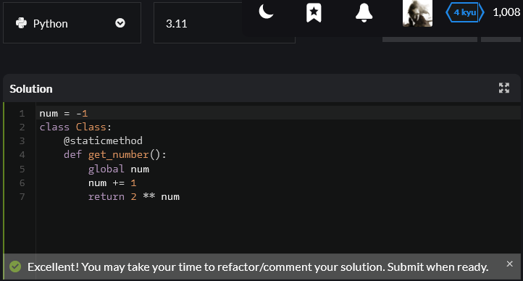

Takeaways:

* Use decorator (@) to specify a static method
* Use global keyword to access global variable in method

Other solutions:

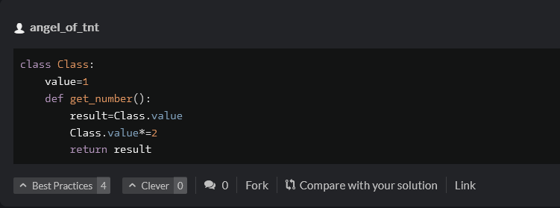

* Use class name to access properties inside class.

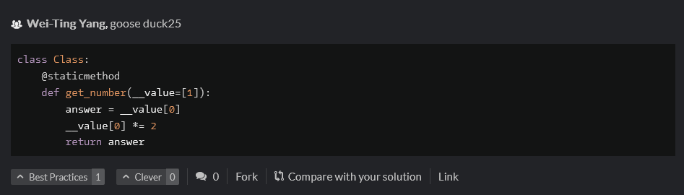

* Not sure wtf going on here.
* It seems variable can be declared inside a function parameter list.



Solution:

* Split the laughing based on the a’s, essentially generating an array of characters being either “h” or “H”.
* Check if array length is zero, then return.
* Otherwise, loop over array starting from second element to the last,
* Increment a counter if the current element is not equal to the element before it.
* Return the final count

Alternative solutions:

* Applies Regexs
* Check if it matches sequences of Ha or sequences of ha,
* Generates array of all matches, if none exists generates empty array,
* Returns length of array.

* No idea what’s happening with this regex